Rework Instruction For HSBUV X01

1. U1201 may populate with incorrect component and its impact HYSNC and VSYNC VGA output signals and may damage BMC pins. Check the component top marking, in case it’s not ‘V25’ for 74LVC2G125DP do one of the following:
   * Replace the component with 74LVC2G125DP (top marking ‘V25’).
   * Remove the component and short pins 2&6 and pins 3&5.  
     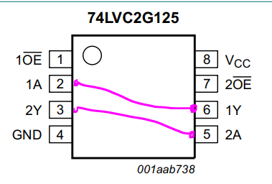
2. Remove R722. This resistor keep Nuvoton RunBMC module in reset.
3. It’s recommended to disable USB power option and use only 12V external power since it may not have the enough power to power the board and module. It may confusing sine the 12V external power and all USB powers are all OR’d together so when 12V is off (e.g., user power cycle) the board will use the USB power that is not enough.

To disable USB power UM: L802, L2002, L2006; and to power the TYPE A USB (bug? It’s powered form P5V_USB instead of VDD_5V) M: L2009.

1. Populate the following locations with 4.7K 1% 0402 pull-up resistors

-R2012, R2013

-R2014, R2015

-R2016, R2017

-R2018, R2019

-R2020, R2021

-R2022, R2023

-R2024, R2025

-R2026, R2027

-R2030, R2031

-R2032, R2033

-R2034, R2035

-R2780, R2781

1. Refer to attached file for physical location on the board



